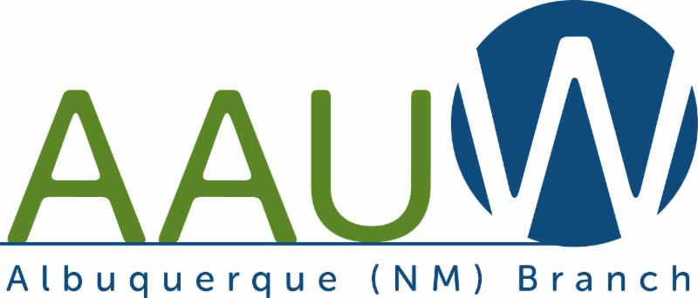

December 2020
Vol. 47 No. 6

AAUW ABQ December Meeting
December 5, 2002
10:00-12:00 Noon
Via Zoom

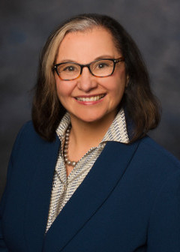
Antoinette Sedillo Lopez

Antoinette Sedillo Lopez will speak at the December meeting. She is a New Mexico State senator serving the 16th District. She is the executive director of Enlace Comunitario.
Enlace Comunitario is a social justice organization led by Latina women in Central New Mexico working to eliminate domestic violence in the Latino immigrant communities and promotes healthy families through: comprehensive domestic violence intervention services, preventative community education, policy advocacy and leadership development. The women Senator Lopez has worked with have not had the opportunities to paths for success that most members of AAUW have had.

Antoinette Sedillo Lopez graduated from the University of New Mexico (UNM) and the UCLA School of Law. She taught law at the UNM for 27 years and remains an emeritus law professor. In addition to her work with Enlace Comunitario, she has also served on the boards of the New Mexico Coalition Against Domestic Violence, Valley Improvement Association Board, Bernalillo County/City of Albuquerque Air Quality Control Board, the Southwest Women’s Law Center, and the New Mexico Hispanic Bar Association.

How and where the legislature will be managed has not been decided. However, this session will be very important with many issues. You will have the opportunity to talk with Senator Sedilio Lopez about issues that are important to you.

After the program, members may choose to attend a breakout session to visit with other members. At the November meeting we did this, and the response was positive. It has been suggested that we have two breakout sessions. The first break out will be for 15 minutes. An announcement will be made that the breakout session will cease in one minute. Then the second one will begin. Individuals may leave the sessions at any time by clicking on LEAVE at the right bottom of the screen. ﻿

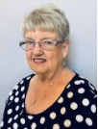
President’s Message

We are approaching a holiday season unlike one most of us have experienced before. Even though most of us have worn masks when in public and attempted to socially distance, the COVID virus continues to spread.
The number of cases has dramatically increased. We are in for a holiday season that this country has not seen since 1918. Not being with family members will be difficult. The good news this week about the possible availability of vaccines in the near future is encouraging. We will continue to meet as a Branch via Zoom until the group meetings are allowed.

Cassandra Osterloh, Librarian at the National Hispanic Center presented a very interesting program on the exhibition at the Center, El Voto Femenino: Sufragistas. Latinos luchando por el derecho al Voto. (The Female Vote: Latino Suffragette Fighting for the Right to Vote.

Cassandra spent over two years seeking information about the fight for women's right to vote in Mexico, Central America, South America, Puerto Rico, Spain and the Philippines. She collected photos and other materials about the women who fought over many years, for the right to vote. Some of the suffragettes lost their lives because they advocated for the right to vote for women.

Unfortunately, the exhibition was scheduled to open in April and close the end of June. The exhibition had to be closed soon after it opened. Cassandra created a slide show of the exhibition. The slide show that she presented at the meeting is available at https://www.nhccnm.org/event/el-voto-femenino-sufragistas-latinas-luchando-por-el-derecho-al-voto/ Cassandra is hoping to develop a video with sound recording of the entire exhibition when the Center reopens. On the website there are activities about the suffragette movement in Spanish speaking countries for adults and children.

This will be a different holiday season. Many are finding creative ways to communicate with family and friends in new ways. My hope is that each of you will find a safe way to celebrate with family and friends over the next month.

Patricia Maben AAUW ABQ President

An anonymous donor in the Albuquerque Branch will do a 2 for 1 dollar match for the first thousand dollars donated to AAUW GREATEST NEED Fund. Checks must be received by Rae Siporin, Branch Treasurer by December 10. Please make out your checks to AAUW Greatest Need Fund. Mail your checks to: Rae Siporin, 179 Loma Del Oro, Corrales, NM 87048-6938.

STEM Task Force

We continue to meet on our regular date, the third Thursday of the month during lunch, with some variability depending on schedule conflicts.

ABQ Branch projects—

We completed the task of sending hand-written graduation congratulations notes to all 2015 Tech Trekkers around the state, thanks to Claudia and Sharon’s hard work.

We are planning the Tech Trek reunions with a different format this year. Since they’ll be virtual, we may have different girls, particularly from far away joining us. Tentatively we’re planning to hold more events, with maybe only girls from one year invited to each reunion, but plans are still up in the air.

With ¡Explora’s! new teen X Studio under construction, we suggested that we could provide contacts for some young teen girls to serve on their Teen Advisory Group. Though they were invited only a day or two before the virtual meeting, three of the local girls we suggested attended.

Tech Trek NM projects—

Tech Trek has received a grant from Honeywell to send STEM-based journals “I Love Science” to all alumnae from 2016-2019. Due to the physical need of being close to
pack these, several members of AAUW ABQ will be the team for this project: Cheri Burch, Claudia Poglitsch, and Dana Roberson.

AAUW recently announced to camp directors that we may only hold Tech Trek virtually this year. AAUW-NM Tech Trek NM estimates their funding needs will only be slightly below the usual amount needed for an in-person camp. Admittedly, there will be no room and board cost, however, there will be additional cost for teaching staff and technology. If you would like to make a donation to this program that serves 60 current 7th-grade girls from across NM, please send a check to:

AAUW Tech Trek NM
P.O. Box 90322
Albuquerque, NM 87199

In June and July there will be two virtual camps, one for the 2020 selectees and one for the 2021 selectees. Donations from last year will be used for the 2020 trekkers this year. While interviews won’t be done for any girls this year, readers will still be needed for 2021 applicants. ﻿Please contact Cheri (ctburch@aol.com) if you’d be available to read this year, so she can send your contact information to the person responsible for readers.

Anyone interested in joining this Task Force would be welcome. Please contact the chair, Cheri Burch, if you have any questions, or just know you’d like to receive the Zoom invitation.

Cheri Burch
Chair, AAUW-ABQ STEM Task Force
Assistant Director, AAUW-NM Tech Trek NM

Glenna Jean Napier

Glenna Jean Getz Napier, age 79, passed away Monday, October 12, 2020. She was born in Anchorage, Alaska on June 24, 1941, to Frank and Harriett Dickson. She was preceded in death by her parents and is survived by her husband, Skip Napier of Albuquerque, NM; children Glenn Geiser-Getz (Amy) of Geneseo, NY and Kristy Getz of Las Vegas, NV whom she shared with her former spouse Leon Getz (Nancy) of Las Cruces, NM; sister, Gloria Heuschkel (Bill) of Grand Rapids, MI; and brother, Frank Dickson (Mary) of Fairview, AZ.

Glenna was born and raised in Anchorage, Alaska. After serving as a teacher, working as an artist, and raising a family there, she moved to the Portland, Oregon area to begin a new chapter in her life. She went back to school, earned her master's degree, and took the opportunity to start a new job. Glenna was never one to be afraid of new experiences. From square dancing to organizing a new art group to volunteering to teach art at the elementary school she took every chance to jump in and learn something new.

Glenna retired in Albuquerque in 2007 and has been an active member of the community ever since. She served as a docent at the Albuquerque Museum and participated in multiple book clubs and visual arts groups related to weaving, quilting, and mixed media. Glenna was an avid international traveler and enjoyed visits to such places as Japan, India, Russia, New Zealand, South Korea, and multiple countries in Europe.

Glenna will be greatly missed by all who knew her. Her smile would light up a room. Glenna joined AAUW in 2009. She was an active member of the West Mesa Branch and joined the Albuquerque Branch after the West Mesa Branch dissolved.

Interest Groups

At the time of publication of this newsletter there is a Governor's Stay at Home Public Health Order. We do not know how long this order will be in place. Below is information about one interest group that meets using Zoom.

MYSTERY. We will be meeting via Zoom at 1:30pm on November 5. Please let Diane know that you will attend by Monday November 30. We will be reviewing Talking About Detective Fiction. Chair: Diane Vadnais, 323-1924.

The Evening Literature group has plans for a December meeting. However at the time of publication there is a Governor's Public Public Health Order that would not allow for a meeting in a member's home.

EVENING LITERATURE. 3rd Mondays, 6:00 p.m. If the Governor's Public Health Orders allow for meetings in homes we will meet on Monday, Dec. 14 at 6:30. Members will be contacted about the meeting place and plans for the meeting. Contact Chair: Sheila Richmond, 280-8904 or sdrich111@comcast.net. for more information.

Calendar

Dec. 5 AAUW ABQ Branch meeting via Zoom. 10:00-12 Noon
Dec. 15 Deadline: nominations for AAUW-NM officers to Nominating Committee Chair
Dec. 15 Deadline: Career Development Grants
Dec. 31 Postmark deadline for AAUW Funds contributions for year
Jan 2 AAUW ABQ Branch meeting
Jan 11 AAUW ABQ Board meeting
Jan. 19 Opening Day State Legislature
Jan. 28 Virtual Convenings begin!
Feb. 6. AAUW ABQ Branch meeting
Feb. TBD Lobby Corps Meetings in Albuquerque/Bernalillo
Feb. TBD Winter State Leadership Team Meeting in Santa Fe
Feb. TBD Legislative Day - Santa Fe, NM
Feb. 10 Deadline to Report Discrepancies in February 2021 Membership Count
Feb. 11 Asian Women Equal Pay Day
Feb. 15 Deadline for Spring Roadrunner
Feb. 16 NCCWSL early-bird registration ends & National Scholarships close
March Women’s History Month
March 6 AAUW ABQ Branch meeting
March 8 International Women’s Day
Mar. 20 Last day of State Legislature
April 3. AAUW ABQ Branch annual meeting
Apr. TBD AAUW-NM Spring Convention
May 1. AAUW ABQ President's Luncheon
May 15 Deadline for Summer Roadrunner
May TBD National Conference for College Women Student Leaders (NCCWSL)
June TBD Tech Trek – 2020 & 2021
Contact Information
AAUW Albuquerque E-mail: aauw.abqnm@yahoo.com
AAUW Albuquerque Branch Website: https://albuquerque-nm.aauw.net
AAUW Albuquerque Mail Address: PO Box 92643, Albuquerque, 87199-2643
Newsletter Editor: Patricia Maben, pam1246@me.com
AAUW New Mexico Website: https://aauw-nm.org
AAUW Website: AAUW.org
Albuquerque Branch of AAUW | PO Box 92643, Albuquerque, NM 87109

